DIRECTION
KS1 – 2007 Paper 2
1.
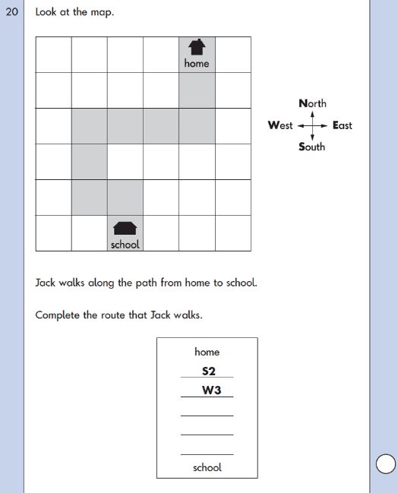
KS1 – 2009 Paper 1
2.

